* Given the provided data, what are three conclusions that we can draw about crowdfunding campaigns?
  + July appears to be the best month to start a campaign as it has the most successful outcomes of 58, but June provides the greatest percentage of success at 64%.
  + Although journalism provides the highest percentage of successful campaigns, I do not believe we have a large enough sample size to draw this conclusion. Theater did have the largest number of successful outcomes at 187, but technology has the greatest percentage of success at 67%.
  + The web subcategory has the greatest percentage of success at 71%. Audio and World Music subcategories were disregarded as the number of campaigns was too low to draw actionable results.
* **What are some limitations of this dataset?**
  + Advertising budgets were not provided as these can drastically impact the outcome of the campaigns. I would be interested in comparing advertising budgets to outcomes to see success rates based on spending tiers. Typically for a fundraising campaign to get off the ground they need to determine their audience and find them on digital or traditional advertising platforms.
* **What are some other possible tables and/or graphs that we could create, and what additional value would they provide?**
  + I feel that adding a scatter plot that incorporates the length of the campaign and the outcome or % successful would add additional value to our analysis. For example, if we could determine the mean duration for a successful campaign, we could use this to boost performance for future initiatives.
  + Did day of the week or time of campaign launch have an impact on the outcome? Adding this filter into the line graph within our sheet could allow us to get even more granular on date, day of the week, and time that has the best chance of success.
  + Since currency and country were provided, I would be interested in charting geo and its relationship to the outcomes. This could provide some insight onto geos with highest percentage of successful.
* **Use your data to determine whether the mean or the median better summarizes the data.**
  + The median better summarizes the data as we are observing many outliners on the box and whiskers plot that are skewing the data.
  + 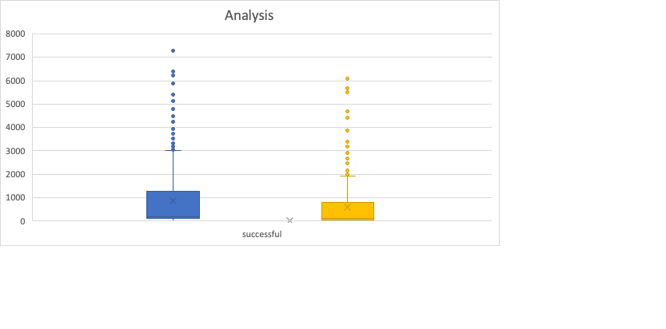
* **Use your data to determine if there is more variability with successful or unsuccessful campaigns. Does this make sense? Why or why not?**
  + There is more variability with the successful data set as there is a higher standard deviation of 1266. This makes sense as the mean is 851 backers with the maximum amount falling at 7295. This data set has more backers falling further from our mean.